**Lab 4 – Invoking Methods, Passing Parameters, Constructors**

**Modify the Lab4 project provided to you on GitHub to complete these requirements:**

Ask the user to provide you with the name, age and marital status of 3 separate individuals.

If any of the 3 persons are married, additionally ask for the first name and age of their spouse.

After you have collected all of this information, compute the average age of all people.

The input and output should look something like this:

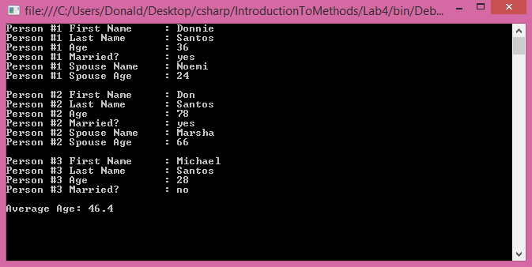

* **Do not modify Program.cs**
* **Do not modify Question.cs**
* Complete the code for the **AverageAge** class
* Complete the code for the **Person** class
* The Person class will be simpler if you utilize the static methods in Question.cs

The following illustration represents the object graph for one example scenario:

